## - - - - - - - - - - COURSE SYLLABUS| MS. JONES| 2025-2026 - - - - - - - - - -

-- - - -

COURSE CONTENT

I am so glad you are here! The purpose of this course is to enhance student’s mastery of Chemistry concepts. This will enable students to make real-world connections and apply their understanding to everyday life.

This course is broken up into various units that will cover different topics within Chemistry. The units of focus are listed here:

## CLASS INFORMATION

### Hephzibah High School

706-592-2089

**Room:** 123

**Instructor**: Ms. J. Jones

**Course:** Chemistry

**Remind:** (@jjonesch(x)) *x = class pd.

**Email:** [jonesja7@boe.richmond.k12.ga.us](mailto:jonesja7@boe.richmond.k12.ga.us) **Website:** [www.rcboe.org/hhs](http://www.rcboe.org/hhs)

## GRADING POLICY

**Unit 1:** Atoms

**Unit 2**: Properties & Bonding  **Unit 3A**: Chemical Reactions  **Unit 3B**: Chemical Reactions **Unit 4:** Solutions, Acids, & Bases

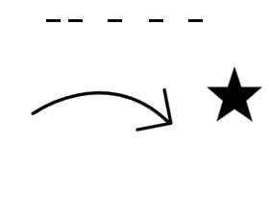

SUPPLIES

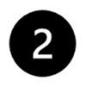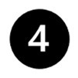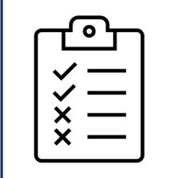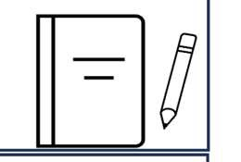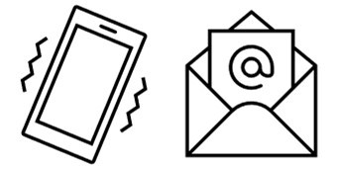

Pencils/Pens/Highlighters 3 ring binder or folder School Issued Laptop Calculator

Colored Pencils

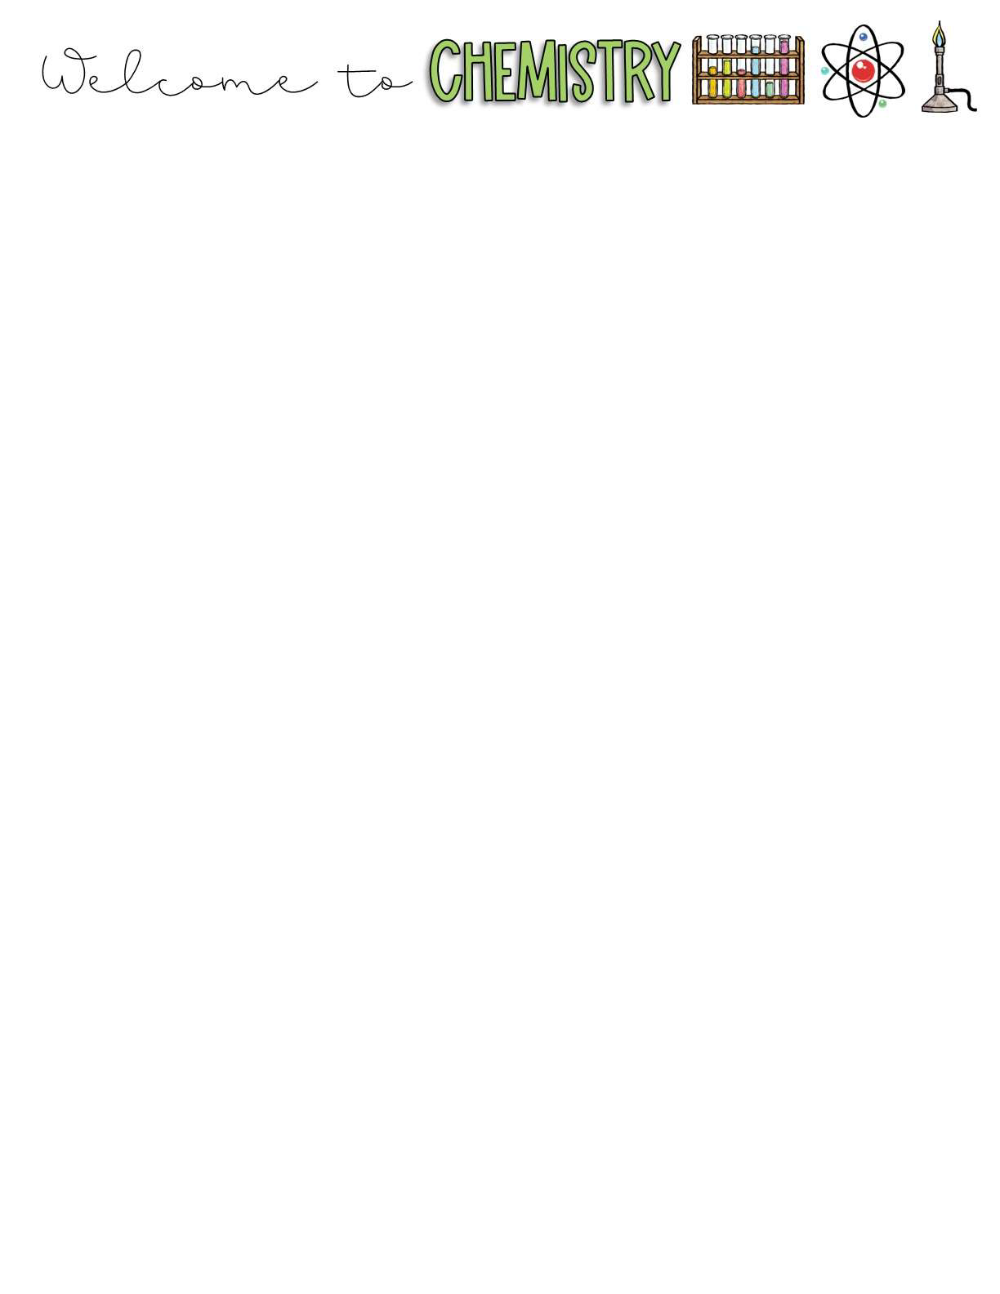Grades will be updated Bi- weekly. The breakdown of how grades will be calculated is as follows:

**Major Assignments: 60%**

Unit Tests, Projects, Labs, etc.

**Minor Assignments: 40%** Quizzes, Vocabulary, assignments, etc.

………………………………… POLICIES ………………………………

……………………

…C…LA…SS…E…X…PE…C…TA…TI…O…NS……

**Supplies:** Students are expected to bring all materials to class each day. Science notebooks are extremely important as they will contain most of the assignments that are completed in class on a daily basis.

**Warm-ups:** Each class period will begin with a warm-up that students will complete as soon as they enter the classroom. These warm-ups will be graded daily within the first 5 minutes of class.

**Make-Up Work:** Make up work will be given after school. It is YOUR responsibility to get YOUR missed work. All assignments are available in Canvas, this will be the easiest way to get missed work.

**Late Work:** Assignments will receive a due date and will be considered late if they are not submitted on time. Students will have 5 days to complete any work that was not submitted by the due date. No additional time will be allotted.

**Class Rules:** Be in your seat on time, Be Respectful, Raise your hand, No eating in class.

## HOMEWORK

Homework is not typically assigned in

## TECHNOLOGY

Cell phones and accessories (smart watch, headphones/earbuds, etc.) are to be turned OFF and put away. The only device that is allowed into the classroom is a SCHOOL ISSUED device.

Unless I specifically say that you may have your electronic devices out, you must keep them away at all

times. If you need to use it for any reason, ask Ms. Jones.

## ABSENCES

Attending class daily is extremely important. If you are absent, it is your responsibility to make-up all the material we covered, including homework. You will be given five days to turn in the missed assignments. It will be your responsibility to turn the work in on your own. If you know in advance that you will be absent, let me know so I

Can give you any assignments That you will need.

## TEXT ALERTS

Join the Remind for the class by signing up for

this class. However, any classwork that is not completed in class should be completed at home. It is encouraged that you use your class time wisely to avoid having to complete assignments at home.

# TEXT

@jjonesch**x**

**x = class pd**

# TO

81010

text alerts! I will notify the class of upcoming due dates, tests, reminders, etc.

*Using this app is crucial for communication with Ms. Jones.

Welcome back! Let’s have the best school year ever! -Ms. Jones

